Objective | Modernized six scenes from The Gift of the Magi💇‍♀️⏱ to fit contemporary settings and relatable situations. Show how modern-day ninth-graders might express love, face challenges, and make sacrifices for people important to them in a way that feels real and relatable.
Introduction | Now it’s your turn to reimagine The Gift of the Magi! This classic story is about love and sacrifice, and your job is to bring it into a modern setting that feels relatable to your life. You can choose to place it in a high school context or somewhere else contemporary—just make it meaningful to you.
What to Modernize | 1. The Situation:  - In the original story, Della and Jim face financial struggles as a married couple, which motivates their sacrifices.  - In your version, think about challenges that make sense for teens in high school. Provide a clear context for why your characters are motivated to give meaningful gifts.  - Maybe your characters don’t have jobs but earn an allowance, or they do extra chores to save money. Perhaps one works a part-time job, babysits, or sells something they care about, like sneakers or a gaming console. Whatever you choose, make their sacrifices feel realistic for their age and experiences.  - The relationship between the characters doesn’t have to be romantic—it just needs to be important. Your story could focus on a boyfriend and girlfriend, best friends, a group of friends, or even family members. Whatever you choose, think about what makes the relationship meaningful and worth sacrificing for.  2. The Gifts:  - In the original, the gifts symbolize their love and sacrifice.  - In your version, think about how you can make the gifts meaningful in terms of what’s valuable to teens today, which could include physical items, digital gifts, or handmade crafts. Meaningful sacrifices might include giving up time, a cherished item, or something for which he or she has worked hard.  - Maybe one character gives up his or her prized AirPods or favorite video game, while the other sells a sentimental keepsake or concert tickets. The gifts don’t have to be expensive—what matters is the thought and sacrifice behind them.  - One character might spend hours creating a personalized playlist filled with meaningful songs, only to discover the other had sold their headphones to buy a special case for their friend’s phone.  - Another might craft a handmade bracelet, only to find that their friend sold a favorite piece of jewelry to buy high-quality art supplies for them.  3. The Irony:  - The original story includes a big twist: Della sells her hair to buy a gift for Jim’s watch, while Jim sells his watch to buy combs for Della’s hair.  - In your version, think about how the sacrifices might clash in a modern way.  - For example, a character sells their favorite skateboard to buy their partner a phone case, only to discover the partner sold their phone to buy new wheels for the skateboard. The twist should highlight how much they care for each other, even if the gifts don’t work out as planned.  4. Communication:  - In the original story, Della and Jim don't communicate their plans, which leads to the surprise and irony of their sacrifices.  - In your version, think about how your characters might show their love or connect in today’s world.  - How might your characters share their plans or feelings? Maybe they text, post on social media, leave voice memos, or use notes in lockers. Think about how teens today express their emotions and how this could add to the story.  5. The Setting:  - The original story takes place in a shared home, but most teens don’t live together or share finances.  - In your version, consider a setting that feels authentic to high school life.  - Maybe your story happens during a school dance, a holiday gift exchange, friendiversary, relationship anniversary (typically weeks or months instead of years), or personal milestone. What spaces or events matter to teens? Keep in mind what feels realistic for the kind of relationships your characters might have at this age.  6. The Values:  - Della and Jim’s story is all about showing love through sacrifice.  - In your version, consider what values are important to your characters and their world.  - Think about themes like friendship, loyalty, or family. How do those values shape the characters’ choices and actions?
Additional Examples | - Romantic Relationships  - Gamer and Cosplayer: She sells her cosplay costume to buy him a limited edition game controller, while he sells his game console to buy her tickets to a big cosplay convention.  - Musician and Painter: She sells her painting supplies to buy him new guitar strings, while he sells his guitar to buy her a new set of brushes.  - Fashionista and Photographer: She sells her designer handbag to buy him a new camera lens, while he sells his camera to buy her a stylish coat.  - Tech Enthusiast and Chef: She sells her cooking equipment to buy him the latest tech gadget, while he sells his tablet to buy her a high-quality chef's knife.  - Bookworm and Athlete: She sells her favorite books to buy him a new pair of running shoes, while he sells his sports gear to buy her a limited edition book set.  - Non-romantic Relationships  - Best Friends: The Gamer and the Artist  - One friend spends hours designing and creating a custom game skin as a surprise gift, while the other sells their favorite art supplies to buy a collector’s edition of their friend’s favorite video game.  - Parent and Child: The Musician and the Memory Keeper  - The child spends their weekends creating a digital scrapbook of family photos and memories to surprise their parent, while the parent sells a cherished vintage guitar to buy the child a set of high-quality headphones for their music practice.  - Siblings: The Athlete and the Builder  - One sibling works hard building a handmade medal display case for their brother or sister, only to find that their sibling has sold a beloved trophy to buy a set of tools to help them with future woodworking projects.  - Friend Group: The Photographer and the Organizer  - A friend spends hours editing and compiling a digital slideshow of their group’s best moments together, while another gives up a concert ticket they worked hard to earn money for, using the funds to buy a new camera lens for their photography-loving friend.  - Parent and Child: The Collector and the Creator  - The child sacrifices a rare card from their collection to buy their parent a special notebook for their journaling, while the parent spends time hand-painting a personalized case for the child’s card collection.

💻 Digital Comic Creation Options | You may create your comic strip using one of the following methods:  Option 1: Google Slides Template  • Make a copy of the provided Google Slides comic template.  • Add images, dialogue, captions, and other details to tell your modernized version of The Gift of the Magi.  • Submit the completed Google Slides file through Google Classroom.  Option 2: Online Comic Creator  You may create your comic using whichever one of these free online tools is available:  • Pixton: https://www.pixton.com  • Storyboard That: https://www.storyboardthat.com  • Canva Comic Strip Maker: https://www.canva.com/create/comic-strips/  If you use an online tool, download your completed comic as an image or PDF and attach it to this assignment in Google Classroom.  ⚠️ Important: Regardless of which option you choose, you must attach your completed comic strip to this assignment before submitting.

Example | First Comic Strip Panel
Student creates, chooses, or chooses and modifies a modernized version of the setting, situation, characters, and gifts of “The Gift of the Magi.” | - Romantic Relationships  - Gamer and Cosplayer: She sells her cosplay costume to buy him a limited edition game controller, while he sells his game console to buy her tickets to a big cosplay convention.
Student figures out how to portray the requested scene in a modernized way, with a relatable situation, and in a high school setting. | 
Student may focus on creating dialogue to portray the scene. | Student may focus on portraying the scene through artistic representation.
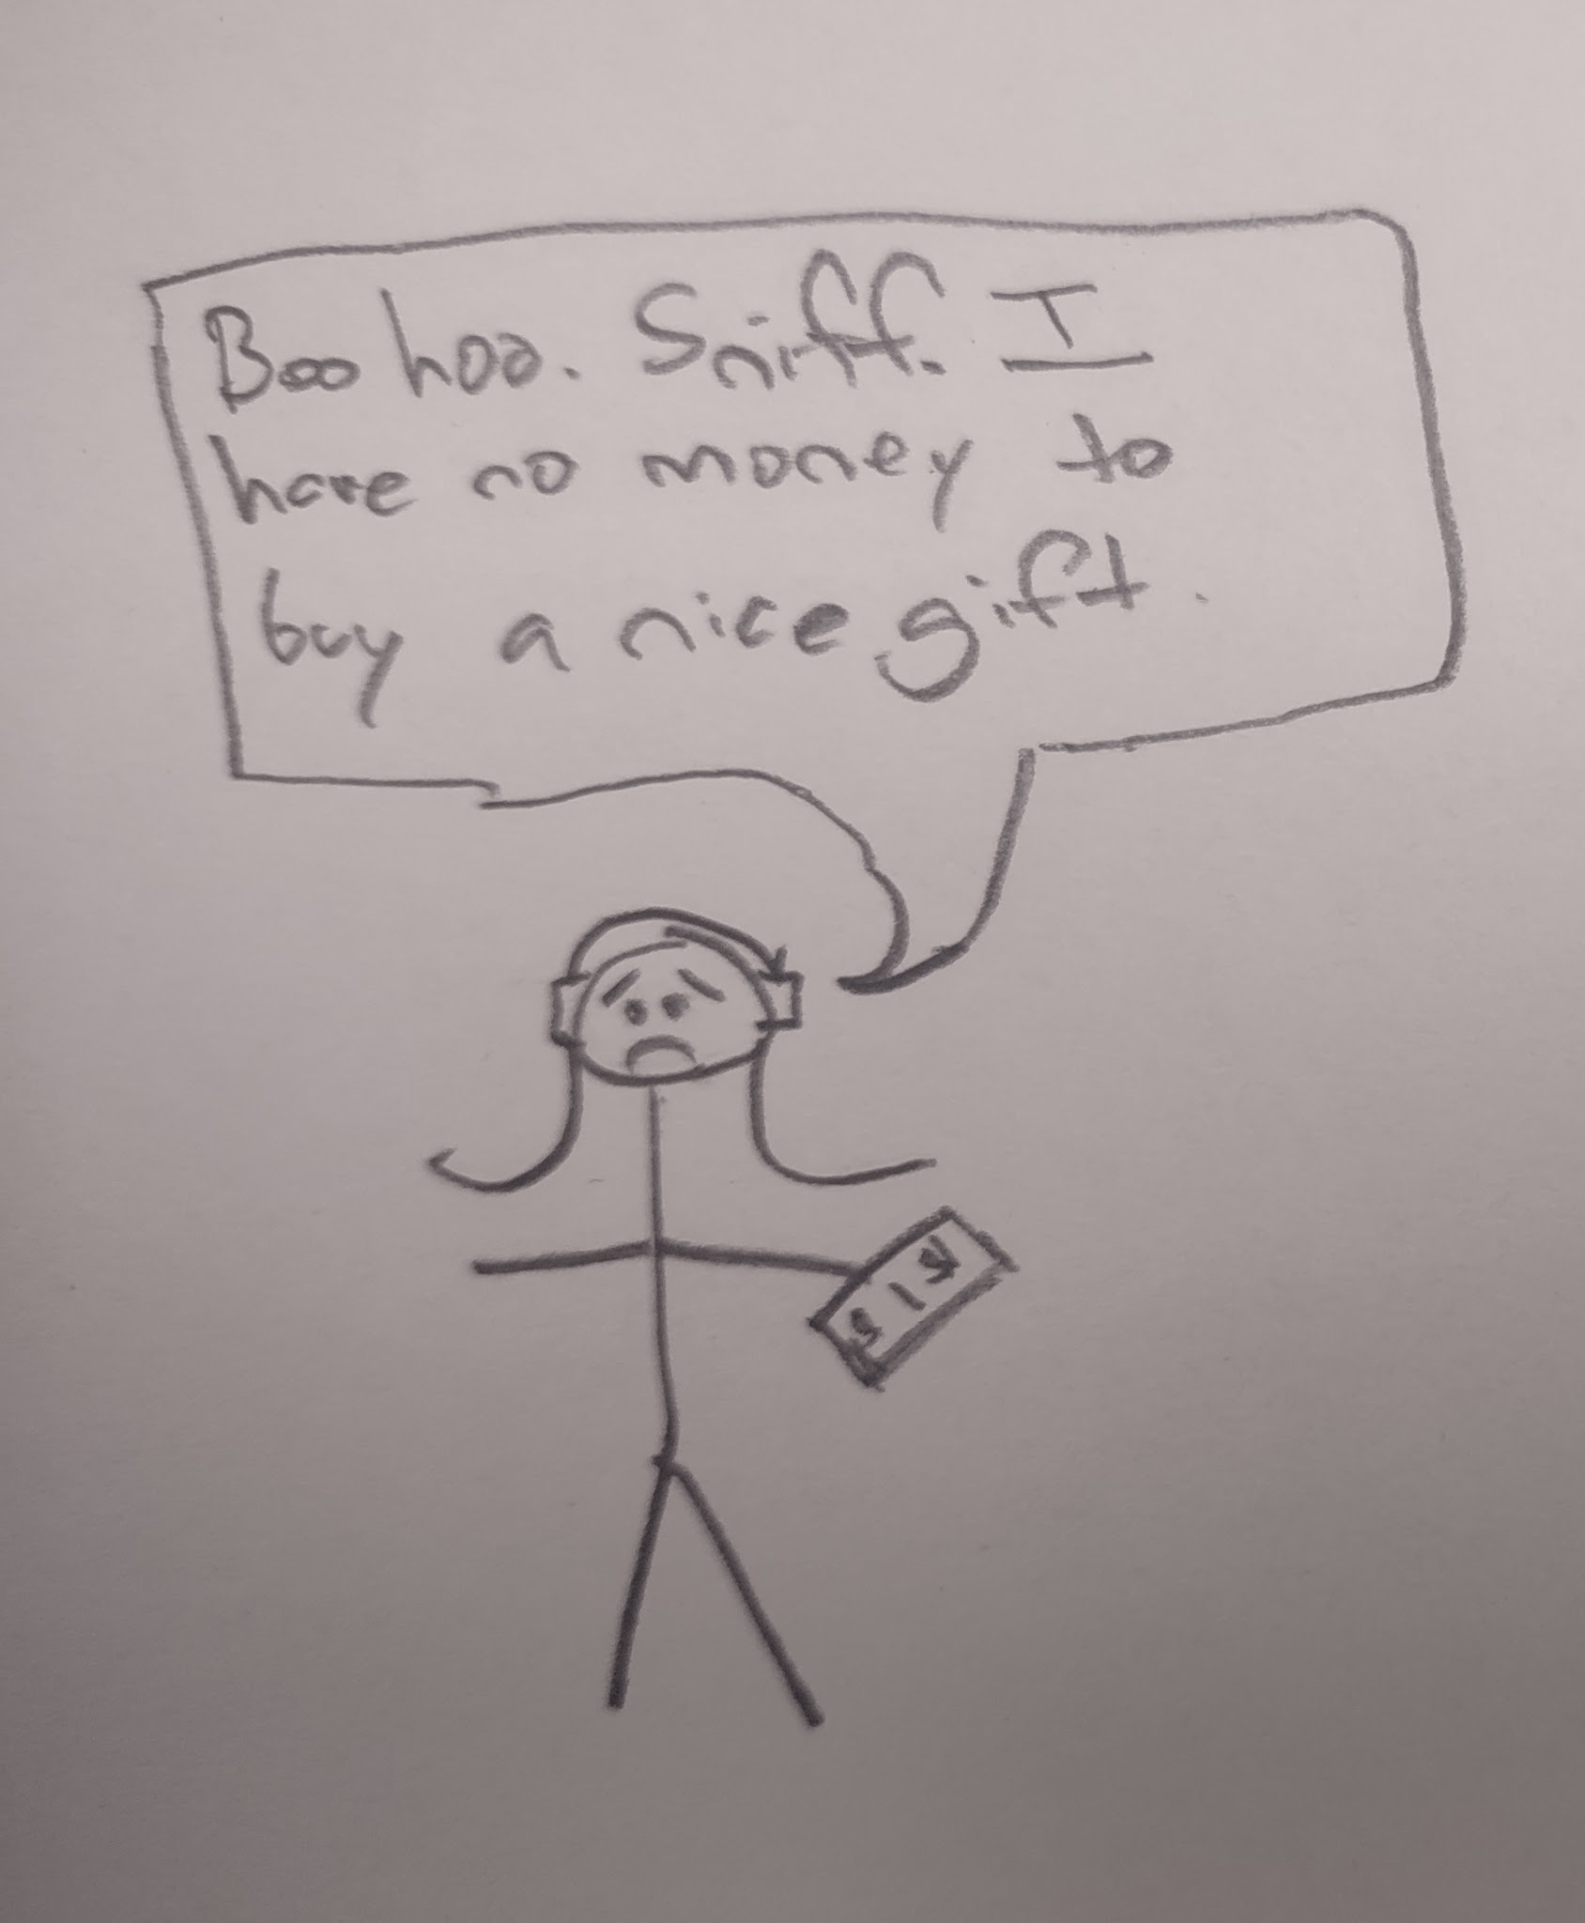 | 